Project Design Phase – II

Technology Stack (Architecture and Stack)

Date | 17 October 2022
Team ID | PNT2022TMID14584
Project Name | Customer Care Registry
Maximum Marks | 4 Marks

Technical Architecture:
The Deliverable shall include the architectural diagram as below and the information as per table 1 and table 2.

Example: Customer Response System
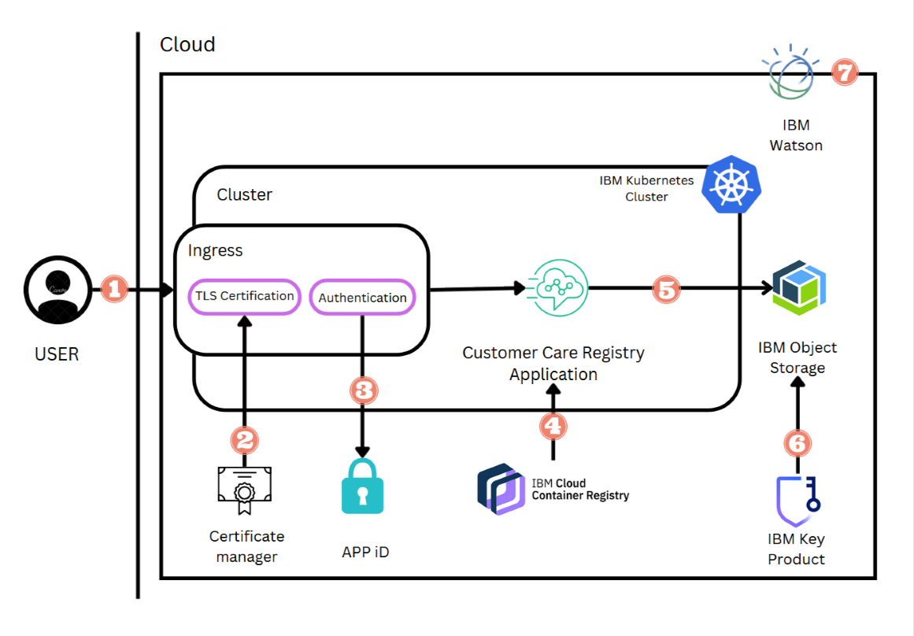

Guidelines:
1. Solution is sent through Email.
2. Data will be stored in IBM Cloud Object Storage.
3. Chatbots will be used.
4. IBM DB2 is used.
Table-1: Components and Technologies:

S. No | Component | Description | Technology
1. | User Interface | All the data in the mobile app | HTML, CSS, JavaScript
2. | Application Logic 1 | Upload the data in IBM Watson | Email
3. | Application Logic 2 | Prepare the Solution | IBM Watson STT Service
4. | Application logic 3 | Deliver the Solution | IBM Watson Assistant
5. | Database | Present Data | MySQL, PySQL, etc.,
6. | Cloud Database | Database Service in Cloud | IBM DB2, IBM Cloudant, etc.,
7. | File Storage | Dashboard | IBM Block Storage
8. | Infrastructure(Server/Cloud) | Application Deployment on Local System/ Cloud Local Configuration: App  Cloud Server Configuration: IBM Cloud | Python, Flask, Kubennetes

Table-2: Application Characteristics:

S. NO | Characteristics | Description | Technology
1. | Open-Source Frameworks | It is classified as a micro framework because it does not require particular tools or libraries. It has no  database abstraction layer, form validation, or any other components where pre- existing third-party libraries provide common functions. | Python Flask Micro-framework
2. | Security Implementations | Including administrative controls, physical security, logical controls, organizational standard | e.g. firewalls, authentication and authorization encryption,data masking
3. | Scalable Architecture | 24/7 customer support means customers can get help and find answers to questions as soon as they come up—24/7 and in real-time. | Chatbot
4. | Availability | This ensures that all of its User and agent related  data is available to the end-users at any time of the  day, whenever and wherever required | Chatbot
5. | Performance | Customers can rate companies with a high customer experience score (i.e. 10/10). | Google Forms

